CHAPA believes that everyone should have a safe, healthy, accessible, and affordable home in communities they choose.

CHAPA has a bold plan to cultivate a stronger housing ecosystem statewide by the end of the decade so that all our people, cities, and towns thrive.

Our plan sets a goal of creating 200,000 homes — including 40,000 affordable and 20,000 deeply affordable homes — by 2030.

As we work towards the goal, we need to ensure housing stability for households that need assistance right now.

We can create more equitable and thriving communities by investing in programs for affordable housing, homelessness prevention, and community development in the FY2024 state budget by focusing on CHAPA’s top budget priorities:

- Invest $250 MILLION in MASSACHUSETTS RENTAL VOUCHER PROGRAM (MRVP) to create 6,000 new vouchers and allow Small Area Fair Market Rents (SAFMRs) to make the vouchers more flexible to use for renting.
- Expand ALTERNATIVE HOUSING VOUCHER PROGRAM (AHVP) with
$26 MILLION investment and allow project basing of AHVP to create more deeply affordable and accessible homes for people with disabilities.
- Preserve PUBLIC HOUSING with $184 MILLION in operating subsidy to ensure housing stability for current and future public housing tenants.
- Restore RESIDENTIAL ASSISTANCE FOR FAMILIES IN TRANSITION (RAFT) with $250 MILLION allocation to allow $10,000 annual benefit and removing burdensome requirement of Notice to Quit for accessing RAFT.
- Fund a STATEWIDE OFFICE OF FAIR HOUSING with $1.5 MILLION to help prevent housing discrimination while ensuring everyone is doing their part to affirmatively further fair housing.

QUESTIONS? Contact CHAPA’s Director of Public Policy Eric Shupin at eshupin@chapa.org or
617-682-9712, or CHAPA’s Senior Policy Advocate Abhi Kurve at akurve@chapa.org or 617-910-7953.

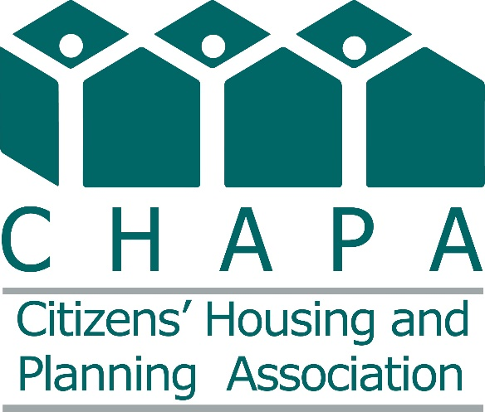

The following lists CHAPA’s FY2024 state budget priorities for affordable housing, community development, and homelessness prevention programs.

Line-Item | Program | FY2024 Requests | SWM FY2024 Budget | House FY2024 Budget | FY2024 Gov’s Budget | FY2023 Budget
7004-9024 | Mass. Rental Voucher Program | $250,000,000 | $179,597,023* | $173,247,567* | $168,247,567 | $154,000,000
7004-9030 | Alternative Housing Voucher Program | $26,000,000 | $16,863,078** | $14,108,528** | $14,108,528 | $13,685,355
7004-9316 | Residential Assistance for Families in Transition | $250,000,000 | $195,000,000 | $180,602,462 | $162,602,462 | $150,000,000
7004-9005 | Public Housing Operating | $184,000,000 | $107,000,000 | $102,000,000 | $92,000,000 | $92,000,000
7004-3036 | Housing Consumer Education Centers | $10,185,000 | $8,974,000 | $9,700,000 | $8,774,000 | $9,700,000
7004-9007 | Public Housing Reform | $7,700,000 | $1,250,000 | $2,200,000 | $2,200,000 | $1,000,000
7004-0104 | Home & Healthy for Good | $8,390,000 | $6,390,000 | $8,890,000 | $4,162,300 | $6,390,000
7004-0108 | HomeBASE | $60,000,000 | $39,570,445 | $42,070,445 | $42,070,445 | $59,411,201
7006-0011 | Foreclosure & Housing Counseling | $3,050,000 | $3,050,000 | $3,050,000 | $1,500,000 | $3,050,000
7004-3045 | Tenancy Preservation Program | $2,000,000 | $2,042,755 | $2,042,755 | $2,042,755 | $1,800,000
4120-4001 | MassAccess Registry | $150,000 | $150,000 | $150,000 | $150,000 | $150,000
4000-0007 | Unaccompanied Homeless Youth | $12,000,000 | $11,000,000 | $10,545,850 | $10,545,850 | $9,500,000
7004-0106 | New Lease for Homeless Families | $250,000 | $250,000 | $250,000 | $250,000 | $250,000
NEW | Fair Housing Trust Fund | $1,500,000 | - | - | - | -
NEW | Access to Counsel Program | $7,000,000 | - | - | - | -
* Includes language to carryover unspent funds from FY23 bringing total FY24 funding for MRVP to an estimated $199.5 million
** Includes language to carryover unspent funds from FY23 bringing total FY24 funding for AHVP to an estimated $26 million

QUESTIONS? Contact CHAPA’s Director of Public Policy Eric Shupin at eshupin@chapa.org or
617-682-9712, or CHAPA’s Senior Policy Advocate Abhi Kurve at akurve@chapa.org or 617-910-7953.

