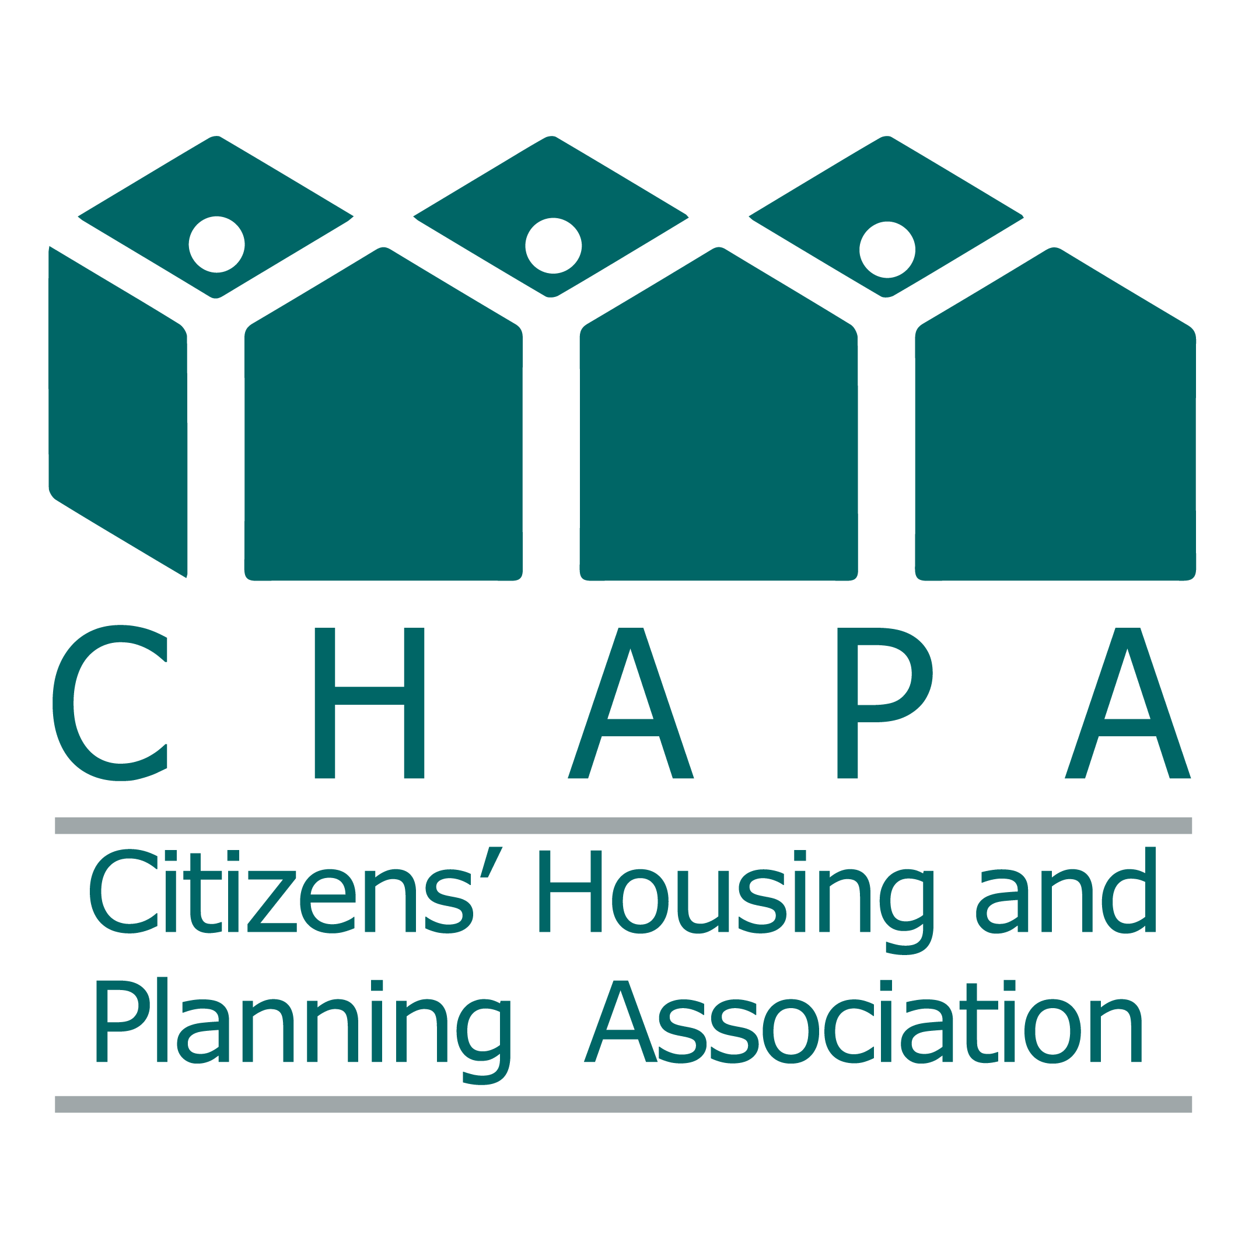
Analysis of Governor Healey’s FY2025 Budget
January 24th, 2024

This document includes an analysis of affordable housing, homelessness prevention, and community development programs in the Governor’s budget as compared to FY2024 budget.
Line-Item | Program | CHAPA FY2025 Requests | Guv’s FY25 Budget | FY24 Budget
7004-9024 | Mass. Rental Voucher Program | $300,000,000 | $219,038,574 | $179,597,023*
7004-9030 | Alternative Housing Voucher Program | $30,000,000 | $16,355,696 | $16,863,078**
7004-9316 | Residential Assistance for Families in Transition | $300,000,000 | $197,406,952 | $190,000,000
7004-9005 | Public Housing Operating | $189,000,000 | $112,000,000 | $107,000,000
7004-3036 | Housing Consumer Education Centers | $12,000,000 | $8,774,000 | $10,474,000
7004-9007 | Public Housing Reform | $7,700,000 | $1,250,000 | $1,315,000
7004-0104 | Home & Healthy for Good | $11,000,000 | $8,390,000 | $8,890,000
7004-0108 | HomeBASE | $80,000,000 | $57,300,000 | $37,070,445
7006-0011 | Foreclosure & Housing Counseling | $3,050,000 | $1,500,000 | $3,050,000
7004-3045 | Tenancy Preservation Program | $2,000,000 | $2,042,755 | $2,042,755
4120-4001 | MassAccess Registry | $300,000 | $150,000 | $150,000
4000-0007 | Unaccompanied Homeless Youth | $15,000,000 | $10,545,850 | $11,000,000
7004-0106 | New Lease for Homeless Families | $250,000 | $250,000 | $250,000
0321-1800 | Access to Counsel Program | $7,000,000 | $3,500,000
NEW | Fair Housing Trust Fund | $2,500,000 | - | -

For more information, contact Abhi Kurve, Senior Policy Advocate, akurve@chapa.org, 617-910-7953 or Matt Noyes, Director of Public Policy, mnoyes@chapa.org.

MASSACHUSETTS RENTAL VOUCHER PROGRAM (7004-9024)

Description of Changes:
- Caps MRVP eligibility criteria of up to 80% AMI at initial eligibility
- Caps targeting MRVP vouchers to households under 30% AMI up to 75% vouchers screened at initial eligibility.
- Changes language of shall to will for the 30% cap on tenant rent share
- Language to define gross rent.
- Removes the language prohibiting the admin fee to be used for inspections.
- Removes the flexibility for project-based vouchers to go beyond the payment standard while retaining it for mobile vouchers.
- Removes the cap on 40% tenant rent share if the Mobile voucher rent is beyond the payment standard (Language changed from shall to may)
- Removes some reporting requirements.
- Removes the language to carry over the unspent funds from FY2024

Language
For the Massachusetts rental voucher program to provide rental assistance for low-income families and elderly persons through mobile and project-based vouchers; provided, that the income of eligible households shall not exceed 80 per cent of the area median income at initial eligibility; provided further, that the executive office of housing and livable communities may require that up to 75 per cent of newly issued vouchers be targeted to households whose income at initial eligibility does not exceed 30 per cent of the area median income; provided further, that the executive office may award mobile vouchers to eligible households currently occupying project-based units that shall expire due to the non-renewal of project-based rental assistance contracts; provided further, that the executive office, as a condition of continued eligibility for vouchers and voucher payments, may require disclosure of social security numbers by participants and members of a participant's household in the Massachusetts rental voucher program for use in verification of income with other agencies, departments and executive offices; provided further, that if a participant or member of a participant's household fails to provide a social security number for use in verifying the household's income and eligibility, then that household shall no longer be eligible for a voucher or to receive benefits from the voucher program; provided further, that a household receiving assistance with a project-based voucher shall pay 30 per cent of its monthly net income towards gross rent, with gross rent defined as the contract rent plus an amount allowed by the executive office for tenant-paid utilities, except that the household payment in any project-based unit that is subsidized under another federal or state subsidy or public housing program shall be subject to applicable limits on tenant paid rent under such federal or state program; provided further, that any household that is proven to have caused intentional damage to its rental unit in an amount exceeding 2 months of rent during any 1-year period shall be terminated from the program; provided further, that if the use of a mobile voucher is or has been discontinued, then the mobile voucher shall be reassigned; provided further, that the executive office shall pay regional administering agencies not less than $50 per voucher per month for the costs of administering the program; provided further, that the executive office shall provide assistance using a payment standard so that the required household payment for a household choosing a unit with gross rent less than or equal to the payment standard will be not more than 30 per cent of the household's monthly net income; provided further, the payment standard shall be set, at the discretion of the executive office, at either 110 per cent of the current area-wide fair market rent or 110 per cent of the current small area fair market rent, both as established by the United States Department of Housing and Urban Development for the same size of dwelling unit in the same region, except as necessary as a reasonable accommodation for a household member with a disability or otherwise directed by the executive office, except that a reduction by the United States Department of Housing and Urban Development in such fair market rental shall not reduce the payment standard applied to a household continuing to reside in a unit without a change in voucher size for which the household was receiving assistance at the time the fair market rent or small area fair market rent was reduced; provided further, that if the gross rent for the unit does not exceed the applicable payment standard, the monthly assistance payment for the household for a mobile voucher shall be equal to the gross rent less the required household payment; provided further, that for a household receiving a mobile voucher under this section, if the household chooses a unit with a gross rent that exceeds the applicable payment standard, the monthly assistance payment for the household shall be limited to the amount by which the applicable payment standard exceeds 30 per cent of the monthly net income of the household; provided further, that even if a household with a mobile voucher chooses a unit with gross rent exceeding the payment standard, at the time the household initially leases that unit with a mobile voucher, the total amount that the household may be required to pay toward gross rent, including the amount by which the gross rent exceeds the payment standard, may not exceed 40 per cent of the monthly net income of the household at the time a household initially leases a dwelling with their mobile voucher; provided further, that a household receiving a mobile voucher under this section may pay more than 40 per cent of the monthly net income of the household, at their option; provided further, that the executive office shall establish the amounts of the mobile and project-based vouchers so that the appropriation in this item shall not be exceeded by payments for rental assistance and administration; provided further, that the executive office shall not enter into commitments that shall cause it to exceed the appropriation set forth in this item; provided further, that the requested rent level for mobile vouchers shall be determined reasonable by the administering agency; provided further, that not later than December 2, 2024, the executive office of housing and livable communities shall submit a report to the house and senate committees on ways and means and the joint committee on housing on the utilization of rental vouchers during the last 3 fiscal years under this item and item 7004-9030; provided further, that the report shall include, but not be limited to, the: (i) number and average value of rental vouchers currently distributed in the commonwealth in each county and in each municipality; (ii) average number of days that it takes for a household to utilize a voucher after receiving it from the administering agency; (iii) number of households that reach the date by which they must lease up their voucher without having found an available unit; (iv) number of households that apply for an extension by the deadline to lease up their voucher and the number of extensions granted; (v) number of distributed vouchers available to be utilized; and (vi) number of families on a waitlist for an available rental voucher; and provided further, that the report shall comply with state and federal privacy standards

ALTERNATIVE HOUSING VOUCHER PROGRAM (7004-9030)

Description of Changes:
- Changes rent limits to ceiling rents.
- Allows AHVP maximum rents to use up to 110% of the Small Area Fair Market Rent except as necessary as a reasonable accommodation.
- Removes the language to carry over the unspent funds from FY2023.

Language
For the rental assistance program established in section 16 of chapter 179 of the acts of 1995; provided, that notwithstanding any general or special law to the contrary, assistance may be provided in the form of either mobile vouchers or project-based vouchers; provided further, that the vouchers shall be in varying dollar amounts set by the executive office of housing and livable communities based on considerations including, but not limited to, household size, composition, household income and geographic location; provided further, that the executive office's approved monthly ceiling rents for vouchers newly issued or leased shall be set, at the discretion of the executive office, at either up to 110 per cent of the current area-wide fair market rent or up to 110 per cent of the current small area fair market rent, except as necessary as a reasonable accommodation for a household member with a disability or as otherwise directed by the executive office, both based on unit size as established annually by the United States Department of Housing and Urban Development for the same size of dwelling unit in the same region; provided further, that the requested rent level for vouchers shall be determined reasonable by the administering agency; provided further, that any household that is proven to have caused intentional damage to its rental unit in an amount exceeding 2 months of rent during any 1-year period shall be terminated from the program; provided further, that notwithstanding any general or special law to the contrary, there shall be no maximum percentage applicable to the amount of income paid for rent by each household holding a mobile voucher; provided further, that unless the executive office implements a payment standard and/or utility allowance for the rental assistance program, that each household may be required to pay not less than 25 per cent of its net income as defined under regulations promulgated by the executive office for units if payment of utilities is not provided by the unit owner or not less than 30 per cent of its income for units if payment of utilities is provided by the unit owner; provided further, that payments for the rental assistance program may be provided in advance; provided further, that the executive office shall establish the amounts of the vouchers so that the appropriation in this item is not exceeded by payments for rental assistance and administration; provided further, that the executive office shall not enter into commitments which shall cause it to exceed the appropriation set forth in this item; provided further, that the amount of a rental assistance voucher payment for an eligible household shall not exceed the rent less the household's minimum rent obligation; and provided further, that not later than December 16, 2024, the executive office shall submit a report to the house and senate committees on ways and means detailing: (i) expenditures from this item; (ii) the number of outstanding rental vouchers; and (iii) the number and types of units leased

RAFT (7004-9316)

Description of Changes:
- Caps RAFT benefit to $7,000 over a 12-month period.
- Removes $3 million set aside for providing assistance to households of all sizes and configurations.
- Removes reporting requirements

Language
For a program to provide assistance in addressing obstacles to maintaining or securing housing for families with a household income: (i) not more than 30 per cent of area median income who are homeless and moving into subsidized or private housing or are at risk of becoming homeless; or (ii) more than 30 per cent but not more than 50 per cent of area median income who are homeless and moving into subsidized or private housing or are at risk of becoming homeless due to a significant reduction of income or increased expenses; provided, that assistance shall be administered by the executive office of housing and livable communities through contracts with the regional HomeBASE agencies unless otherwise procured; provided further, that not less than 50 per cent of the funds shall be provided to households with an income not more than 30 per cent of area median income, subject to the executive office's discretion based on data reflecting program demand and usage; provided further, that in distributing 50 per cent of the funds, the executive office shall prioritize those families most likely to otherwise require shelter services under item 7004-0101; provided further, that the amount of financial assistance shall not exceed $7,000 in any 12-month period; provided further, that residential assistance payments may be made through direct vendor payments according to standards to be established by the executive office; provided further, that the agencies shall establish a system for referring families approved for residential assistance payments, who the agencies determine would benefit from these services, to existing community-based programs that provide additional housing stabilization supports, including assistance in obtaining housing subsidies and locating alternative housing that is safe and affordable for any such families; provided further, that the program shall be administered under guidelines established by the executive office; provided further, that income verification shall be conducted by using: (a) documentation provided by the household, requiring the same documentation and process used to conduct income verification under this item in fiscal year 2024 or fewer documents as directed by the executive office; (b) third-party income verification; or (c) validated receipt of certain MassHealth or department of transitional assistance benefits demonstrating that the household earns less than 50 per cent of area median income; provided further, that the manner in which income verification is conducted shall be at the discretion of the executive office but that the executive office shall not discontinue the use of said options for income verification listed in the preceding proviso; provided further, that the executive office shall allow a short, simple application requiring minimal processing time; provided further, that the executive office shall submit quarterly reports to the house and senate committees on ways and means detailing the: (1) number of families who applied for assistance; (2) number of families approved for assistance; (3) minimum, median and average amount of financial assistance awarded; (4) total amount of assistance awarded to date, including a breakdown by income category; and (5) number of families falling into each income category; provided further, that household assistance funds shall be advanced to the administering agencies at the end of each month and prior to the next month's disbursement, the amount of which shall be estimated based on the prior month's expenditure with a reconciliation not less than annually; provided further, that notwithstanding clauses (i) and (ii), funds shall be expended to families and individuals who are at risk of injury or harm due to domestic violence in their current housing situation and whose household income is not more than 60 per cent of the area median income; and provided further, that families and individuals that are at risk of injury or harm from domestic violence who meet the qualifications of enrollment in the address confidentiality program shall be afforded the opportunity to register with and become enrolled in the address confidentiality program as offered by the secretary of the commonwealth

HOUSING CONSUMER EDUCATION CENTERS (7004-3036)

Description of Changes:
- Removes housing stabilization earmark
- Removes reporting requirement
- Removes funding to support the Regional Housing Network

Language
For housing services and counseling; provided, that funds shall be expended as grants to 9 regional housing consumer education centers operated by the regional nonprofit housing authorities unless administering agencies are otherwise procured by the executive office; and provided further, that the funds shall be awarded through a competitive application process under criteria created by the executive office

PUBLIC HOUSING OPERATING (7004-9005)

Description of Changes:
- Allocates the Public housing funds under new Housing Secretariat (Executive Office of Housing and Livable Communities)
- Removes the $50,000 earmark for Just-A-Start
- Removes Elderly preference.
- Removes language that exempts Housing Authorities from funding cuts as a result of communities’ non-compliance to 3A

Language

For subsidies to housing authorities and nonprofit organizations, including funds for deficiencies caused by certain reduced rentals in housing for the elderly, handicapped, veterans, families and relocated persons under sections 32 and 40 of chapter 121B of the General Laws; provided, that the executive office of housing and livable communities may expend funds appropriated under this item for deficiencies caused by certain reduced rentals which may be anticipated in the operation of housing authorities for the first quarter of the subsequent fiscal year; provided further, that no funds shall be expended from this item to reimburse the debt service reserve included in the budgets of housing authorities; provided further, that no funds shall be expended from this item in the AA object class for the compensation of state employees; provided further, that the amount appropriated in this item shall be considered to meet all obligations under said sections 32 and 40 of said chapter 121B; provided further, that new reduced rental units developed in fiscal year 2025 eligible for subsidies under this item shall not cause any annualization that results in an amount exceeding the amount appropriated in this item; provided further, that all funds in excess of normal utilities, operations and maintenance costs may be expended for capital repairs; provided further, that no employee of a housing authority shall simultaneously be an elected executive officer within the same municipality in which the authority is located; and provided further, that the administration shall make every attempt to direct efforts toward rehabilitating local housing authority family units requiring $10,000 or less in repairs

HOMEBASE (7004-0108)

Description of Changes:
- Limits HomeBASE benefit to citizens and lawful residents.
- Removes 90-day notice requirement for changes to regulations.
- Removes reporting requirements.

Language

For a program of short-term housing assistance to help families eligible for temporary emergency shelter under item 7004-0101 in addressing obstacles to maintaining or securing housing; provided, that the assistance shall include not less than 12 months of housing stabilization and economic self-sufficiency case management services for each family receiving benefits under this item; provided further, that a family shall not receive more than $30,000 in a 24-month period from this item; provided further, the executive office of housing and livable communities shall provide household assistance in an amount up to $15,000, or a higher cap established in item 7004-0108, for a subsequent 12-month period to eligible families; provided further, that not less than $2,500,000 shall be made available to administering agencies for circumstances in which the administering agency believes an award greater than $30,000 in a 24-month period is essential to resolve a housing crisis, in accordance with guidance from the executive office of housing and livable communities; provided further, that so long as a family meets the requirements of its housing stabilization plan, a family that received household assistance under this item whose income increases shall not become ineligible for assistance due to exceeding the income limit; provided further, that a family shall not be deemed ineligible as a result of any single violation of a self-sufficiency plan; provided further, that the executive office of housing and livable communities shall take all steps necessary to enforce regulations to prevent abuse in the short-term housing transition program, including a wage match agreement with the department of revenue; provided further, that a family that was terminated from the program or did not make a good faith effort to follow its housing stabilization plan during the term of its assistance shall be ineligible for benefits under said item 7004-0101 and this item for 12 months from the last date the family received financial assistance under said item 7004-0101 and this item; provided further, that a family's housing stabilization plan shall adequately accommodate the ages and disabilities of the family members; provided further, that families receiving benefits under this program who are found ineligible for continuing benefits shall be eligible for aid pending a timely appeal under chapter 23B of the General Laws; provided further, that families who are denied assistance under this item may appeal that denial under said chapter 23B, including subsection (F) of section 30 of said chapter 23B and regulations adopted to implement said chapter 23B; provided further, that benefits under this item shall only be provided to residents of the commonwealth who are citizens of the United States or persons lawfully admitted for permanent residence or otherwise permanently residing under the color of law in the United States; provided further, that the executive office, as a condition of continued eligibility for assistance under this program, may require disclosure of social security numbers by all members of a family receiving assistance under this item for use in verification of income with other agencies, departments and executive offices; provided further, that if a family member fails to provide a social security number for use in verifying the family's income and eligibility, then the family shall no longer be eligible to receive benefits from this program; provided further, that the executive office shall administer this program through the following agencies, unless administering agencies are otherwise procured by the executive office: the Berkshire Housing Development Corporation; Central Massachusetts Housing Alliance, Inc.; Community Teamwork Inc.; the Housing Assistance Corporation; the Franklin County regional housing and redevelopment authority; Way Finders, Inc.; Metro Housing Boston; the Lynn housing authority and neighborhood development; the South Middlesex Opportunity Council, Inc.; NeighborWorks Housing Solutions; and RCAP Solutions, Inc.; provided further, that the executive office shall reallocate funding based on performance-based statistics from underperforming service providers to above average service providers in order to move as many families from hotels, motels or shelters into more sustainable housing; provided further, that the executive office shall use funds provided under this program for stabilization workers to focus efforts on housing retention and to link households to supports, including job training, education, job search and child care opportunities available, and may enter into agreements with other public and private agencies for the provision of such services; provided further, that a stabilization worker shall be assigned to each household; provided further, that funds shall be used to more rapidly transition families served by the program into temporary or permanent sustainable housing; provided further, that the executive office shall expend funds under item 7004-0108 on families residing in temporary emergency shelters and family residential treatment or sober living programs under items 4512-0200 and 4513-1130 if said families otherwise meet all eligibility requirements applicable to emergency shelter under item 7004-0101, except that, solely for the purposes of this item, the fact that a family is residing in a temporary emergency domestic violence shelter under item 4513-1130 or in a family residential treatment or sober living program under item 4512-0200 shall not preclude said family from receiving assistance; provided further, that this item shall be subject to appropriation and, in the event of a deficiency, nothing in this item shall give rise to, or shall be construed as giving rise to, any enforceable right or entitlement to services in excess of the amounts appropriated in this item; and provided further, that household assistance funds shall be advanced to the administering agencies at the end of each month and before the next month's disbursement, the amount of which shall be estimated based on the prior month's expenditure with a reconciliation not less than annually

HOUSING CONSUMER EDUCATION CENTERS (7006-0011)

Description of Changes:
- Removes the Housing Stabilization pilot and other earmarks.
- Removes reporting requirements.

Language

For housing services and counseling; provided, that funds shall be expended as grants to 9 regional housing consumer education centers operated by the regional nonprofit housing authorities unless administering agencies are otherwise procured by the executive office; and provided further, that the funds shall be awarded through a competitive application process under criteria created by the executive office

HOME and HEALTHY FOR GOOD (7004-0104)

Description of Changes:
- Removes MHSA as an administrator
- Removes the $500,000 set aside for a Permanent Supportive housing pilot

Language

For the home and healthy for good program operated by Massachusetts Housing and Shelter Alliance, Inc. to reduce the incidence of chronic and long-term homelessness in the commonwealth; provided, that not less than $250,000 shall be expended to continue a supportive housing initiative for unaccompanied homeless young adults who identify as lesbian, gay, bisexual, transgender, queer or questioning; provided further, that Massachusetts Housing and Shelter Alliance, Inc. shall be solely responsible for the administration of this program; provided further, that not later than March 3, 2025, the Massachusetts Housing and Shelter Alliance, Inc. shall submit a report to the clerks of the house of representatives and the senate, the executive office of housing and livable communities, the joint committee on housing, and the house and senate committees on ways and means detailing: (i) the number of people served, including available demographic information; (ii) the average cost per participant; (iii) whether participants have previously received services from the executive office; and (iv) any projected cost-savings to the commonwealth associated with this program; provided further, that not less than $500,000 shall be expended for a statewide permanent supportive housing program to serve people experiencing long-term homelessness and who have complex medical and behavioral health needs for the purpose of ending homelessness, promoting housing stability and reducing costly utilization of emergency and acute care; and provided further, that not later than March 3, 2025, the Massachusetts Housing and Shelter Alliance, Inc. shall submit a report to the clerks of the house of representatives and the senate, the executive office of housing and livable communities, the joint committee on housing and the house and senate committees on ways and means detailing: (a) the number of people served, including available demographic information; (b) the average cost per participant; (c) whether participants have previously received services from the executive office; and (d) any projected cost savings associated with this program for the executive office or in the utilization of emergency and acute care

FORECLOSURE AND HOUSING COUNSELING (7006-0011)

Description of Changes:
- Lowers the amount of retained revenue from licensure fees from $3.05 million to $1.5 million
- Removes the $1.5 million minimum set aside for foreclosure and housing counseling grants.

Language
For the division of banks, which may expend for the costs associated with the licensure of loan originators under chapter 255F of the General Laws an amount not to exceed $1,500,000 from the revenue received from administrative fees associated with licensure fees and from civil administrative penalties under chapter 255F; provided, that funds in this item may be expended as competitive grants for the operation of a pilot program for best lending practices, first-time homeowner counseling for non-traditional loans and 10 or more foreclosure education centers under section 16 of chapter 206 of the acts of 2007; and provided further, that notwithstanding any general or special law to the contrary, for the purpose of accommodating timing discrepancies between the receipt of revenues and related expenditures, the department may incur expenses and the comptroller may certify for payment amounts not to exceed the lower of this authorization or the most recent revenue estimate, as reported in the state accounting system

ACCESS to COUNSEL (0321-1800)

Language

For an access to counsel program; provided, that subject to appropriation, funds shall be distributed by the Massachusetts Legal Assistance Corporation to designated non-profit organizations to increase access to legal representation for low-income tenants and low-income owner occupants in eviction proceedings

